

File Sharing App In Tizen

**App was developed by- The Unknowns  
  
Members**

|  |  |
| --- | --- |
| **Md. Reazul Koswer Talukder**  Student Department of Electrical and Computer Engineering North South University [reazul.taukder@northsouth.edu](mailto:reazul.taukder@northsouth.edu) | **Tausif Imam**  Student Department of Electrical and Computer Engineering North South University tausif.imam@northsouth.edu |
| **Worked On- All API** | **Worked On- Bluetooth API** |
| **S.M. Tonmoy Rahman Khan**  Student Department of Electrical and Computer Engineering North South University [tonmoy.khan@northsouth.edu](mailto:tonmoy.khan@northsouth.edu) | **Md. Saiful Islam**  Student Department of Electrical and Computer Engineering North South University [islam.saiful@northsouth.edu](mailto:islam.saiful@northsouth.edu) |
| **Worked On- UI API** | **Worked On- Contacts API** |

**Under the supervision of**

|  |
| --- |
| **Muhammad Abdullah - Al - Baki**  **Chief Engineer  Samsung R&D Institute Bangladesh Ltd Monem Business District 111, Bir Uttam C. R. Dutta Road Dhaka - 1205, Bangladesh** |

**Project Description**

In this app we have implemented a system that will perform operation over two Tizen OS phone that will share contact through Bluetooth and save it.

Generally when we want to add contact in our phone we have to type the name and also the number or go to call log which is a lengthy process.

But our app doesn’t have this kind of difficulties.

**Use Case**

**Connecting the phones through Bluetooth**

* At first we turn on the Bluetooth.
* Taken the necessary sample Bluetooth API code from tizen forum. And implement it as per our need.
* Secondly, we searched for the MAC id of another phone through our implemented code.
* The searching process has given us a confirmation massage that the MAC id has received and MAC id of the device is shown
* Finally we bond the two phone in the same Bluetooth connection.

**Sending the contact**

* First we type the name and contact number that we want to send.
* We used “|” after typing contact name to differentiate between contact and number
* By pressing the send button, we send the massage to other phone and wait for the acceptation.
* When the other device press the accept button the massage has received.

**Saving the contact**

* After receiving, the phone need to save the contact in the phone book.
* By pressing the save button the contact number with its name has saved.

**Flow Chart of Our Application**

***Sender End***

**Send**

Type:Name|Number

**Bond**

Search for other device

**Pair**

**Change visibility**

***Select:* Send contact via buletooth**

*Receiver end*

**Save contact**

**Receive Contact via Bluetooth**

**Accept contact**

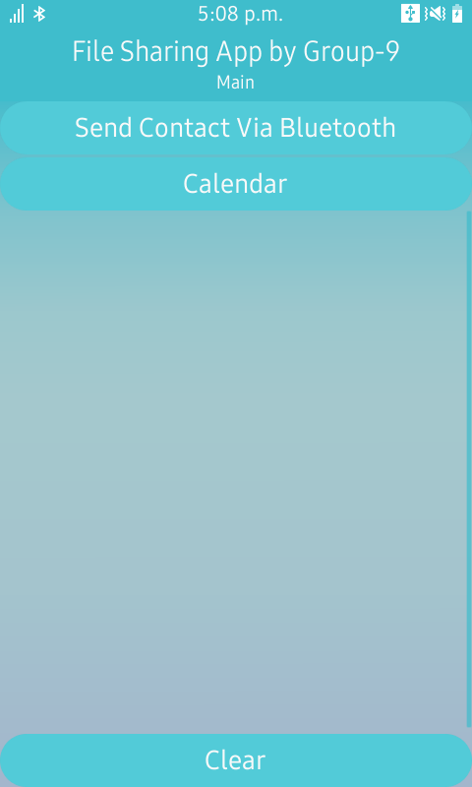**Screenshots**

To share contacts we need to do following steps

**Step-1:** We have to open the App and select

“send Contact via Bluetooth”.

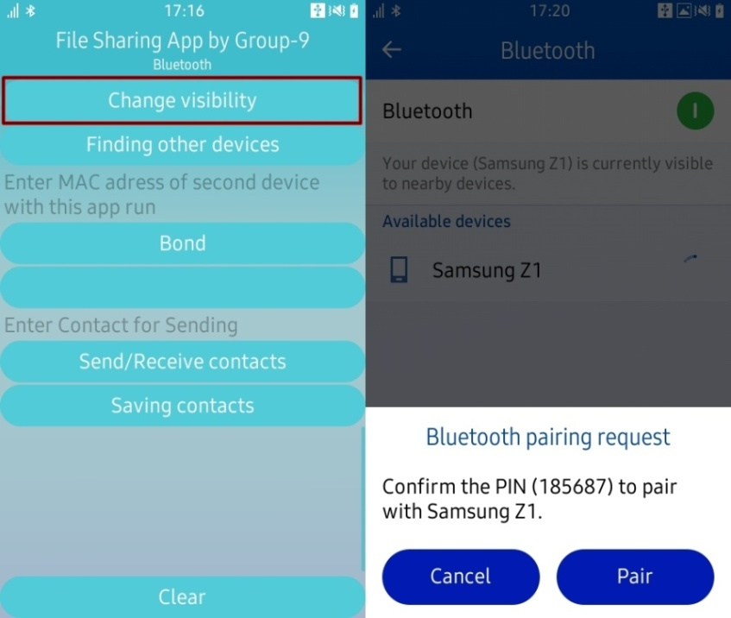

**Step-2:** We have to pair the Bluetooth with

the receiver side Bluetooth, to do that

we have to lick on the Change visibility and

select receiver side device

**Step-3:** We need to make sure paring is ok, to do that we click on “Finding on other devices” if pairing is ok then MAC address of that device will appear.  
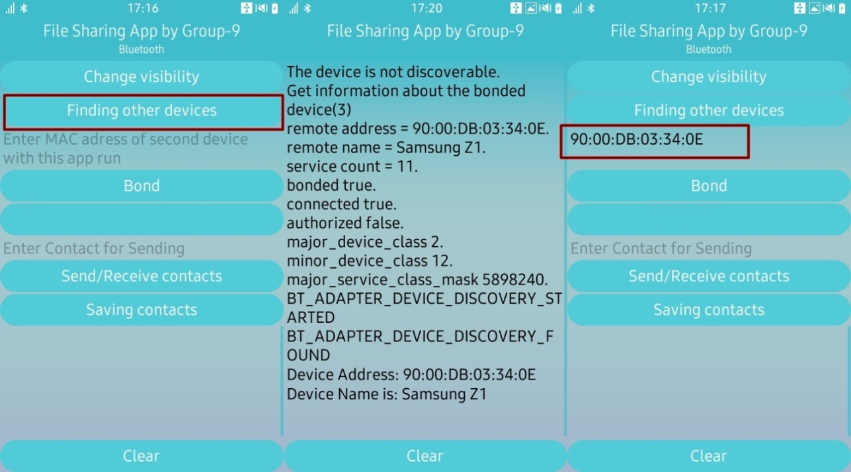  
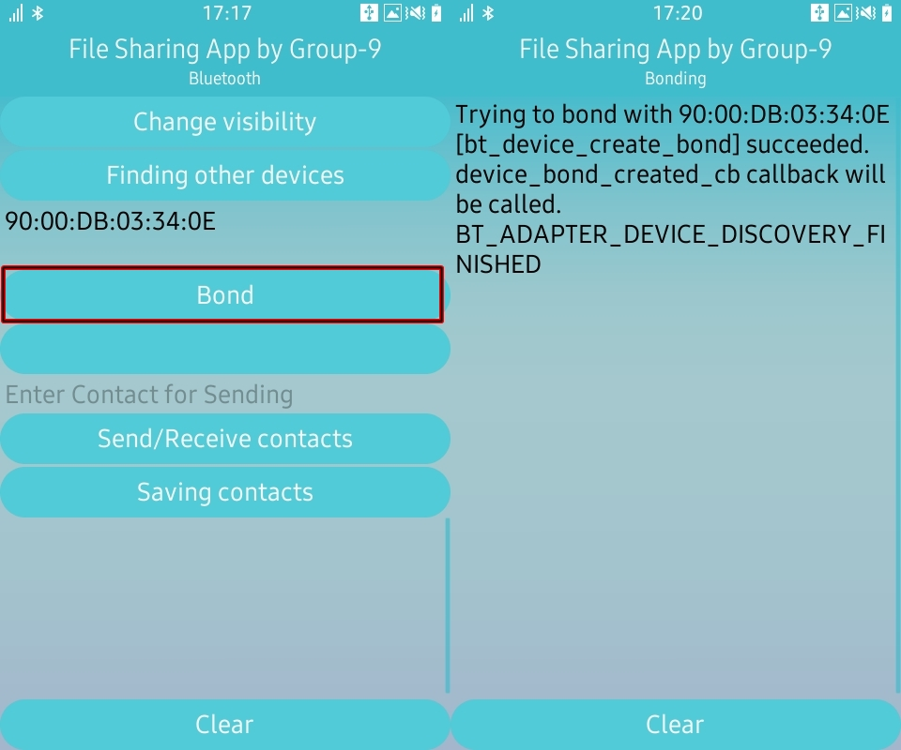

**Step-4:** We will now bond the device, by clicking bond

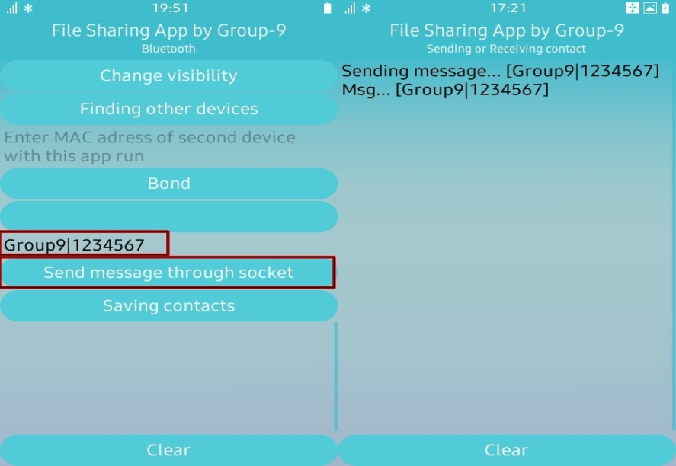**Step-5**: Now we are ready to send contacts, type the “contact name” then “|” followed by the “contact number”

**Step-6:** In the receiver side click on “send/receive contacts”.  
  
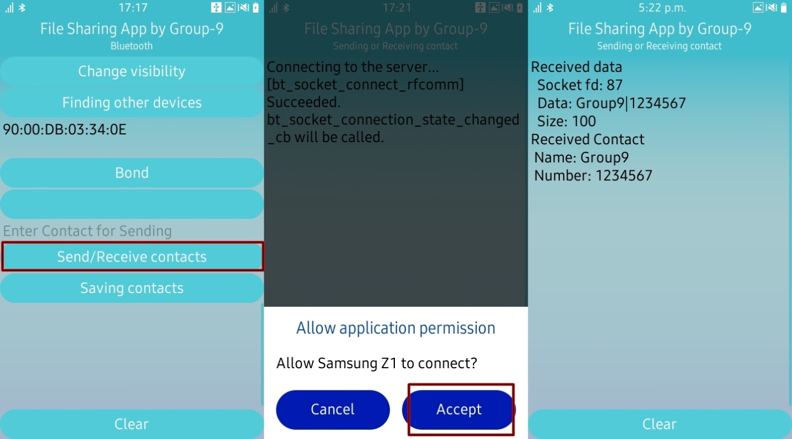

**Step-7:** After receiving the data click on saving contact then check the contacts where the contact is saved or not.  
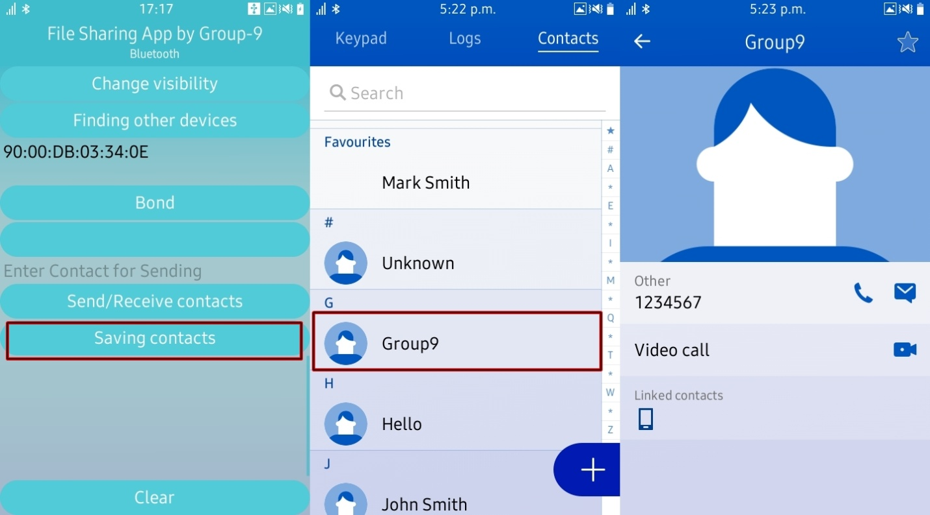

**API Used for Applicaton**

File sharing app will help you in sharing contacts of person

and save in the database easily. We have used two APIs.

They are Bluetooth and Contacts.

## Source code link

<https://github.com/reazul-talukder/file_sharing_app_RnD>

